Software Requirement Specifications
Web-Based Car Rental Management System



Submitted by
Student Name: Mujtaba Rehman
Roll No: S25BINFT7M04049

Submitted to
Supervisor Name: Sir Zaman Ali Sb

Department of Information Technology
Faculty of Computing
The Islamia University of Bahawalpur

Meeting Details
Sr No | Details | Date | Supervisor Signature
Summary

The Web-Based Car Rental Management System is an online platform developed to automate the car rental process for customers and administrators. It allows users to register, log in, search available cars, view car details, book vehicles, and make online payments easily. Customers can also manage their bookings and view rental history.

The system provides an admin panel where administrators can manage cars, customers, bookings, payments, and generate reports. It reduces manual work, saves time, improves accuracy, and enhances customer satisfaction through a user-friendly interface.

This project is built using web technologies such as HTML, CSS, JavaScript, PHP, and MySQL. It is designed to be secure, responsive, and efficient for modern car rental businesses.

Table of Contents
1. Introduction 4
1.1. Purpose 4
1.2. Scope 4
1.3. Product Perspective 4
1.4. User Characteristics 4
1.5. Similar apps and systems/Literature Review 4
1.6. Proposed Technologies 4
2. Requirements 5
2.1. Function Requirements 5
2.1.1. Sign Up 5
2.2. Non-Functional Requirements 5
3. Use Cases and Flow of Processes 6
3.1. Use Case 1 7
4. References 8

- Introduction
The Web-Based Car Rental Management System is an online platform designed to simplify and automate the process of renting vehicles. Traditional car rental systems often rely on manual record-keeping and in-person interactions, which can be time-consuming and prone to errors. This system aims to overcome these limitations by providing a centralized, web-based solution that allows users to access services anytime and from anywhere.
The system enables customers to search for available cars, view details, make reservations, and manage bookings through a user-friendly interface. At the same time, administrators can efficiently manage vehicle inventory, customer records, bookings, and payments.
By integrating modern web technologies, the system enhances operational efficiency, reduces paperwork, and improves the overall user experience. It is designed to be scalable, secure, and easy to use, making it suitable for both small and large car rental businesses.
  - Purpose

The purpose of this Software Requirements Specification (SRS) document is to provide a detailed description of the Web-Based Car Rental Management System. It outlines the system’s functional and non-functional requirements, intended users, system features, and overall structure. This document serves as a reference for developers, designers, and stakeholders involved in the project.
  - Scope

The Web-Based Car Rental Management System is designed to automate and manage car rental services through an online platform. The system will allow customers to browse available vehicles, make bookings, and manage reservations. Administrators will be able to manage vehicles, users, bookings, and payments. The system aims to improve efficiency, reduce manual workload, and enhance customer experience.Product Perspective
Define that how your developed module will be fit in the system.
  - User Characteristics
• Customers:
Basic knowledge of web browsing. They can search for cars, register, log in, and book vehicles.
• Admin:
Skilled users responsible for managing cars, users, bookings, and reports.
• Staff (optional):
May assist in updating vehicle availability and handling bookings.
  - Similar apps and systems/Literature Review
• Online platforms like car rental websites provide vehicle booking and payment services.
• Existing systems focus on automation of reservations and fleet management.
• The proposed system improves usability and provides a centralized platform for both customers and administrators.
gs
  - Proposed Technologies
• Frontend: HTML, CSS, JavaScript (React or similar framework)
• Backend: PHP
• Database: MySQL
• Server: Apache
• Other Tools: Payment Gateway API, Google Maps API (optional)

- Requirements
  - This section describes the functional and non-functional requirements of the Web-Based Car Rental Management System. These requirements define what the system should do and how it should perform
  - Function Requirements

Functional requirements specify the core features and operations of the system.
    - Sign Up
- Users must be able to create an account.
- The system should collect user details (name, email, password, phone number).
- Validation must be applied to ensure correct data entry.
- Users should receive confirmation upon successful registration.

Additional Functional Requirements
- Login/Logout functionality
- Search and filter cars
- View car details (price, availability, specifications)
- Book a car
- Cancel or modify bookings
- Admin can add, update, or delete cars
- Admin can manage users and bookings
- Payment processing
.
  - Non-Functional Requirements
• Performance: System should respond within 2–3 seconds.
• Security: User data must be encrypted and protected.
• Usability: User-friendly interface for all types of users.
• Reliability: System should be available 24/7 with minimal downtime.
• Scalability: Should support increasing users and vehicles.
• Compatibility: Must work on all modern browsers and devices.

- Use Cases and Flow of Processes
Actor: Customer
Description:
A new user registers in the system to access car rental services.
Flow of Events:
- User opens the registration page.
- User enters personal details.
- System validates input data.
- System stores user data in the database.
- User receives confirmation and can log in.
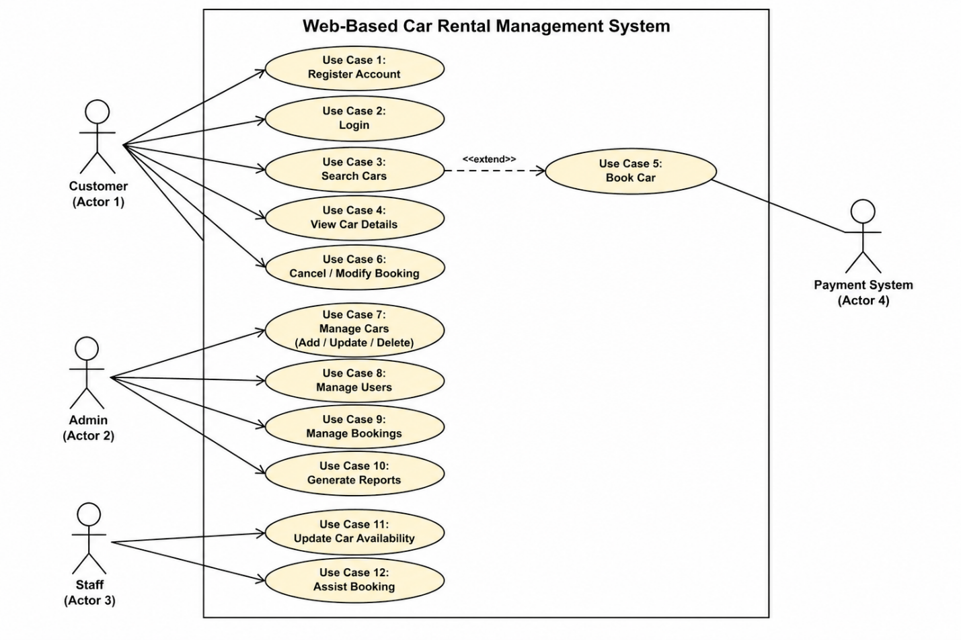
Figure 1: System Level Use Case Diagram

c

  - Use Case 1
Customer Use Cases | Customer Use Cases
Use Case ID Use Case Name Description Relationship  UC-01 Register Account User creates a new account —  UC-02 Login User logs into the system —  UC-03 Search Cars User searches available cars —  UC-04 View Car Details User views details of selected car —  UC-05 Book Car User books a car Extends UC-03  UC-06 Cancel/Modify Booking User edits or cancels booking — | Use Case ID Use Case Name Description Relationship  UC-01 Register Account User creates a new account —  UC-02 Login User logs into the system —  UC-03 Search Cars User searches available cars —  UC-04 View Car Details User views details of selected car —  UC-05 Book Car User books a car Extends UC-03  UC-06 Cancel/Modify Booking User edits or cancels booking —
Admin Use Cases | Admin Use Cases
Use Case ID Use Case Name Description Relationship  UC-07 Manage Cars Add, update, or delete car records —  UC-08 Manage Users Manage customer accounts —  UC-09 Manage Bookings View and manage all bookings —  UC-10 Generate Reports Generate rental and financial reports — | Use Case ID Use Case Name Description Relationship  UC-07 Manage Cars Add, update, or delete car records —  UC-08 Manage Users Manage customer accounts —  UC-09 Manage Bookings View and manage all bookings —  UC-10 Generate Reports Generate rental and financial reports —
Staff Use Cases (Optional) | Staff Use Cases (Optional)
Use Case ID Use Case Name Description Relationship  UC-11 Update Car Availability Update status of cars —  UC-12 Assist Booking Help customers with booking process — | Use Case ID Use Case Name Description Relationship  UC-11 Update Car Availability Update status of cars —  UC-12 Assist Booking Help customers with booking process —
External System Use Case | External System Use Case
Use Case ID Use Case Name Description Relationship  UC-13 Process Payment Handle payment transactions Linked with UC-05 (Book Car) | Use Case ID Use Case Name Description Relationship  UC-13 Process Payment Handle payment transactions Linked with UC-05 (Book Car)
Diagrams
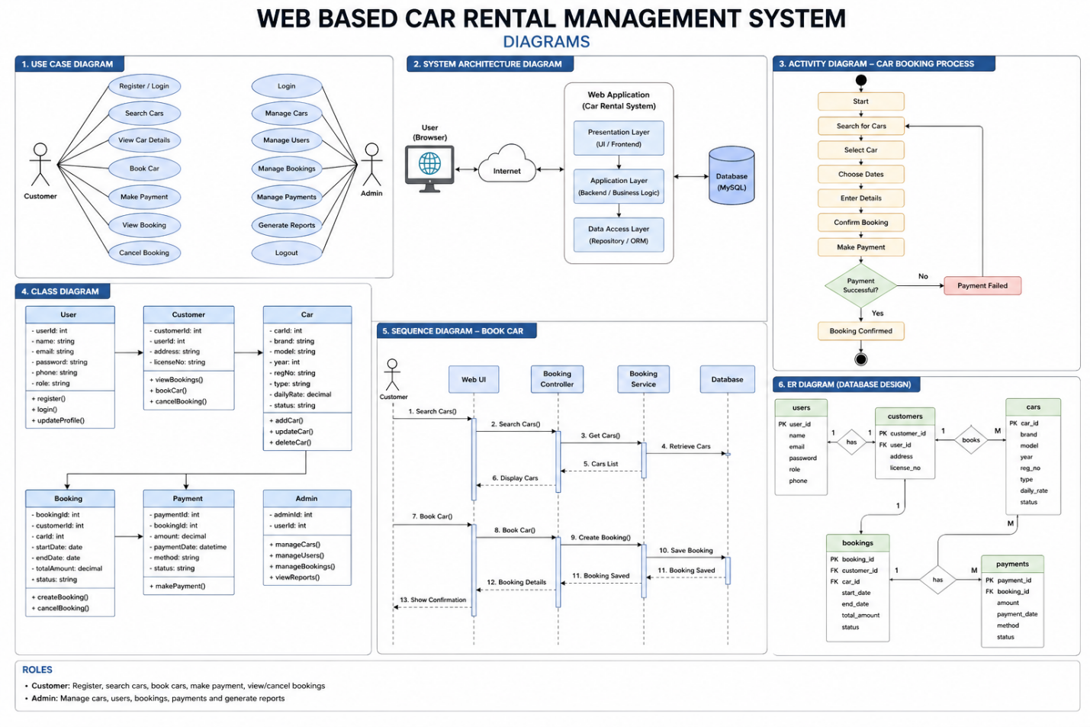
- References
• Software Engineering Books and Notes
• IEEE SRS Documentation Standards
• Online documentation for web development technologies
• Existing car rental platforms for reference

